**Zomato Case Study SQL Queries**

1. **Total amount spent by each customer**

select s.userid, sum(p.price) as total_amount_spent

from sales s

inner join product p

on s.product_id = p.product_id

group by s.userid;

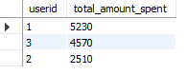

1. **Number of visits to the website by each customer**

select userid, count(distinct created_date) as num_of_visit

from sales

group by userid;

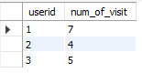

1. **First product purchased by each customer**

with cte as

(select *,

rank() over(partition by userid order by created_date) as rnk

from sales)

select *

from cte

where rnk = 1;

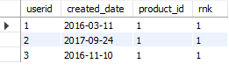

**4a. Most purchased product on the menu**

select product_id

from sales

group by product_id

order by count(product_id) desc

limit 1;



**4b. Number of times was it purchased by each customer**

select userid, count(product_id) as count_of_purchase

from sales

where product_id = (

select product_id

from sales

group by product_id

order by count(product_id) desc

limit 1)

group by userid

order by 1;

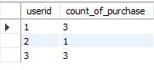

**5. Most popular item for each customer**

with cte1 as

(select userid, product_id, count(product_id) as purchase_count

from sales

group by userid, product_id),

cte2 as

(select *,

rank() over(partition by userid order by purchase_count desc) as rnk

from cte1)

select *

from cte2

where rnk = 1;

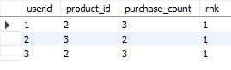

**6. First product purchased by each customer after becoming a member**

with cte1 as

(select s.*, g.gold_signup_date

from sales s

inner join goldusers_signup g

on s.userid = g.userid

and s.created_date >= g.gold_signup_date),

cte2 as

(select *,

rank() over(partition by userid order by created_date) as rnk

from cte1)

select userid, product_id

from cte2

where rnk = 1;



**7. Last product purchased by each customer before becoming a member**

with cte1 as

(select s.*, g.gold_signup_date

from sales s

inner join goldusers_signup g

on s.userid = g.userid

and s.created_date <= g.gold_signup_date),

cte2 as

(select *,

rank() over(partition by userid order by created_date desc) as rnk

from cte1)

select userid, product_id

from cte2

where rnk = 1;



**8. Total number of orders and amount spent by each customer before becoming member**

with cte1 as

(select s.*, g.gold_signup_date

from sales s

inner join goldusers_signup g

on s.userid = g.userid

and s.created_date <= g.gold_signup_date),

cte2 as

(select c1.*, p.price

from cte1 as c1

inner join product p

on c1.product_id = p.product_id)

select userid, count(created_date) as num_of_orders, sum(price) as amount_spent

from cte2

group by userid

order by 1;

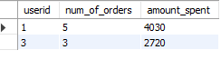

**9. Suppose, buying each product generates purchasing points (5 Rs = 2 Zomato points) e.g. 5 Rs spent on p1 generates 1 Zomato point, for p2 10 Rs = 5 Zomato points and for p3 5 Rs = 1 Zomato point**

**a. Calculate points collected by each customer**

with cte1 as

(select s.*, p.price

from sales s

inner join product p

on s.product_id = p.product_id),

cte2 as

(select c1.userid, c1.product_id, sum(price) as amount_spent

from cte1 c1

group by c1.userid, c1.product_id

order by 1),

cte3 as

(select *,

case when product_id = 1 then 5

when product_id = 2 then 2

when product_id = 3 then 5 else 0 end as points

from cte2 as c2),

cte4 as

(select *, round(amount_spent/points, 0) as points_earned

from cte3)

select userid, sum(points_earned) as points_earned_by_each_customer, sum(points_earned)*2.5 as total_cashback_earned

from cte4

group by userid;

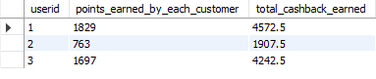

**b. For which product most points have been given till now**

with cte1 as

(select s.*, p.price

from sales s

inner join product p

on s.product_id = p.product_id),

cte2 as

(select c1.userid, c1.product_id, sum(price) as amount_spent

from cte1 c1

group by c1.userid, c1.product_id

order by 1),

cte3 as

(select *,

case when product_id = 1 then 5

when product_id = 2 then 2

when product_id = 3 then 5 else 0 end as points

from cte2 as c2),

cte4 as

(select *, round(amount_spent/points, 0) as points_earned

from cte3)

select product_id, sum(points_earned) as points_earned_by_each_product

from cte4

group by product_id

order by 2 desc;

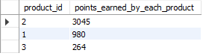

**10. In the first year after a customer joins the Gold program (including their join date), irrespective of what product the customer has purchased, they earn 5 zomato points for every 10 Rs spent**

**Who earned more between 1 and 3 and how much points had they earned in the first year**

with cte as

(select s.*, g.gold_signup_date

from sales s

inner join goldusers_signup g

on s.userid = g.userid

and s.created_date >= g.gold_signup_date

and s.created_date <= adddate(g.gold_signup_date, 365))

select c.*, p.price, p.price*0.5 as total_points_earned

from cte c

inner join product p

on c.product_id = p.product_id;

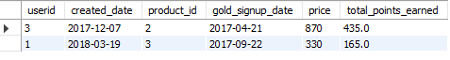

**11. Rank all the transactions of the customers**

select *,

rank() over(partition by userid order by created_date) as rnk

from sales;

**12. Rank all the transactions for each Gold member and for each non-gold member transactions display N/A**

with cte as

(select s.*, g.gold_signup_date

from sales s

left join goldusers_signup g

on s.userid = g.userid

and s.created_date >= g.gold_signup_date)

select *,

case when gold_signup_date is null then 'N/A' else rank() over(partition by userid order by created_date desc) end as rnk

from cte;